11.74: a) The center of gravity of top block can be as far out as the edge of the lower block. The center of gravity of this combination is then 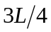 from the right edge of the upper block, so the overhang is 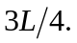
b) Take the two-block combination from part (a), and place it on the third block such that the overhang of is from the right edge of the third block; that is, the center of gravity of the first two blocks is above the right edge of the third block. The center of mass of the three-block combination, measured from the right end of the bottom block, is 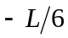 and so the largest possible overhang is 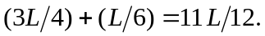
Similarly, placing this three-block combination with its center of gravity over the right edge of the fourth block allows an extra overhang of 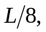 for a total of 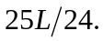 c) As the result of part (b) shows, with only four blocks, the overhang can be larger than the length of a single block.

